DATABASE SCHEMA(CONNECTION)

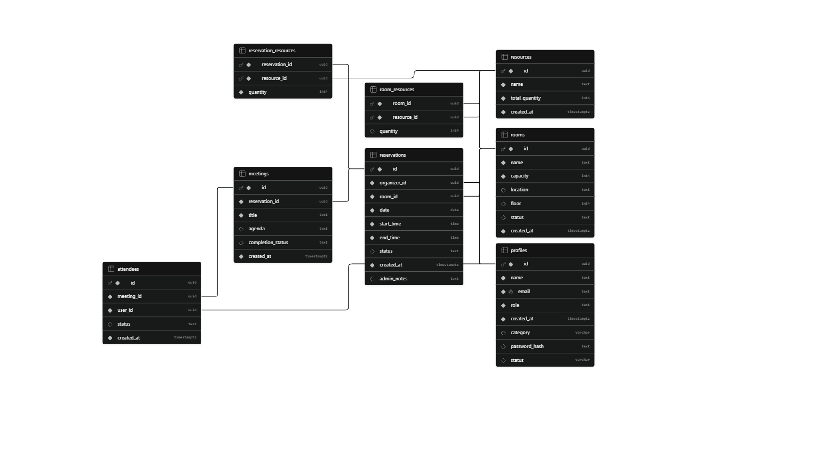

CRUD OPERATIONS
Module | Create (C) | Read (R) | Update (U) | Delete (D)
Authentication | Register (POST /auth/register) | Login (POST /auth/login) | Reset Password | —
Rooms | POST /rooms | GET /rooms | PUT /rooms/:id, PUT /rooms/:id/status | DELETE /rooms/:id
Resources | POST /resources | GET /resources | PUT /resources/:id | DELETE /resources/:id
Reservations | POST /reservations | GET /reservations, GET /available-rooms, GET /calendar, GET /pending | PUT /reservations/:id, PUT /reservations/:id/status | DELETE /reservations/:id
Attendees | — | GET /attendees/user/:userId | PUT /attendees/:id/status | —
Notifications | — | GET /notifications/:userId | PUT /notifications/:id/read, PUT /notifications/user/:userId/read-all | —
Feedback | POST /feedback | GET /feedback, GET /feedback/user/:userId | — | —
Audit Logs | POST /audit/log | GET /audit | — | —
Policies | — | GET /policies | PUT /policies/:key | —
Users | POST /users | GET /users | PUT /users/:id, PUT /users/:id/status | DELETE /users/:id
Meeting Records | — | GET /records | — | —
Statistics | — | GET /stats/* | — | —
Health Check | — | GET /health | — | —

Overall CRUD Mechanism

Create
- Register new users
- Create rooms
- Create resources
- Submit reservation requests
- Submit meeting feedback
- Create user accounts
- Log audit events

Read
- View rooms and resources
- Search available rooms
- View reservations and calendar
- View attendees and notifications
- View users, feedback, policies, statistics, meeting records, and audit logs

Update
- Update room information and status
- Update resource information
- Approve, reject, or modify reservations
- RSVP to meeting invitations
- Mark notifications as read
- Update policy values
- Update user profiles and activation status
- Reset user passwords

Delete
- Delete rooms
- Delete resources
- Cancel/Delete reservations
- Delete users

AUTHENTICATION

Authentication Mechanism
- User Registration
  - User submits Name, Email, Password, Role, and Category.
  - System validates the input and creates a new account.
  - A JWT token is generated and returned upon successful registration.
- User Login
  - User enters Email and Password.
  - Credentials are verified against stored user data.
  - On successful authentication, a JWT token (24-hour validity) is issued.
  - The response includes the authenticated user's profile (ID, name, email, role, and category).
- JWT-Based Authorization
  - The client stores the JWT token.
  - For all protected endpoints (e.g., /rooms, /reservations, /users), the token is sent in the Authorization: Bearer <token> header.
  - The server validates the token before granting access.
- Password Reset
  - The UI includes Forgot Password and Reset Password forms.
  - The document indicates that users can request a reset link and set a new password using a reset token.
  - However, the API specification does not define the corresponding endpoints for these operations.

REST APIs

Based on your API specification, the Authentication REST APIs are:
Method | Endpoint | Description | Authentication
POST | /auth/register | Register a new user account | ❌ Not Required
POST | /auth/login | Authenticate user and return JWT token | ❌ Not Required

1. Register API
Endpoint
POST /api/auth/register
Request Body
{
"email": "user@example.com",
"password": "secret123",
"name": "John Doe",
"role": "Organizer",
"category": "faculty"
}
Response (201 Created)
{
"message": "Registration successful",
"token": "eyJhbG...",
"user": {
"id": "uuid",
"name": "John Doe",
"email": "user@example.com",
"role": "Organizer",
"category": "faculty"
}
}

2. Login API
Endpoint
POST /api/auth/login
Request Body
{
"email": "user@example.com",
"password": "secret123"
}
Response (200 OK)
{
"message": "Login successful",
"token": "eyJhbG...",
"user": {
"id": "uuid",
"name": "John Doe",
"email": "user@example.com",
"role": "Admin",
"category": "faculty"
}
}

Authentication Workflow
User Registration
│
▼
POST /api/auth/register
│
▼
Account Created + JWT Token
│
▼
User Login
│
▼
POST /api/auth/login
│
▼
JWT Token Returned
│
▼
Authorization: Bearer <JWT>
│
▼
Access Protected APIs

Protected APIs
After successful login, the JWT token is used to access secured endpoints, including:
- /rooms
- /resources
- /reservations
- /attendees
- /notifications
- /stats
- /feedback
- /audit
- /records
- /policies
- /users
The API specification indicates that the Forgot Password and Reset Password forms exist in the application, but it does not define REST API endpoints for these features.

BUSINESS LOGIC

Overall Project Business Logic

1. User Authentication and Authorization
- Users register and log in using email and password.
- Passwords are securely stored as hashes.
- Upon successful authentication, the system issues a 24-hour JWT token.
- All protected APIs require a valid JWT.
- Access is controlled using Role-Based Access Control (RBAC):
  - Admin: Full system management.
  - Organizer: Create and manage meeting reservations.
  - Attendee: View invitations, RSVP, and submit feedback.

2. Room and Resource Management
- Admins create, update, and delete meeting rooms.
- Admins manage shared resources (e.g., projectors, whiteboards).
- Each room can be associated with one or more resources.
- Room availability depends on reservation schedules and room status.

3. Reservation Management
- Organizers search for available rooms based on:
  - Date
  - Start time
  - End time
  - Minimum capacity
- The system validates each reservation request by checking:
  - Working hours policy
  - Maximum bookings per user
  - Time-slot conflicts
  - Resource availability
  - Faculty priority policy
- Valid requests are stored with Pending status.
- Administrators can:
  - Approve reservations
  - Reject reservations
  - Request modifications
- Organizers may update and resubmit modified reservations.
- Reservations can be cancelled only before the configured cancellation deadline.

4. Meeting and Attendee Management
- Creating a reservation automatically creates the corresponding meeting record.
- Organizers can invite attendees using their email addresses.
- Attendees receive meeting invitations.
- Attendees respond by accepting or declining invitations (RSVP).
- Attendance status is maintained for each meeting.

5. Notification Management
- Users receive notifications for reservation updates.
- Notifications include events such as:
  - Reservation approval
  - Reservation rejection
  - Modification requests
- Users can mark individual or all notifications as read.

6. Feedback Management
- After meetings, organizers and attendees submit ratings and comments.
- Feedback evaluates:
  - Room quality
  - Equipment
  - Meeting experience
  - Overall satisfaction
- Duplicate feedback for the same reservation is prevented.

7. User Management
- Administrators create Organizer and Admin accounts.
- Administrators update user information.
- User accounts can be activated or deactivated.
- Administrators can delete user accounts.

8. Policy Management
Administrators configure system-wide policies including:
- Working hours
- Maximum bookings per user
- Cancellation deadline
- Faculty priority
- Other reservation rules
These policies are automatically enforced during reservation processing.

9. Audit Logging
- Important system activities are recorded, including:
  - User login
  - Reservation creation
  - Reservation approval/rejection
  - Administrative actions
- Administrators can search audit logs for monitoring and accountability.

10. Reporting and Statistics
The system provides dashboard statistics for different user roles:
- Admin: Rooms, resources, pending requests, active users, recent reservations.
- Organizer: Upcoming meetings, pending requests, approved and rejected meetings.
- Attendee: Today's meetings, upcoming meetings, accepted and pending invitations.

